Random name

**About us Treatments Hospitals Dentists Alternate Medicine Contact Us**

**-1-**

Random name

**About us Treatments Hospitals Dentists Alternate Medicine Contact Us**

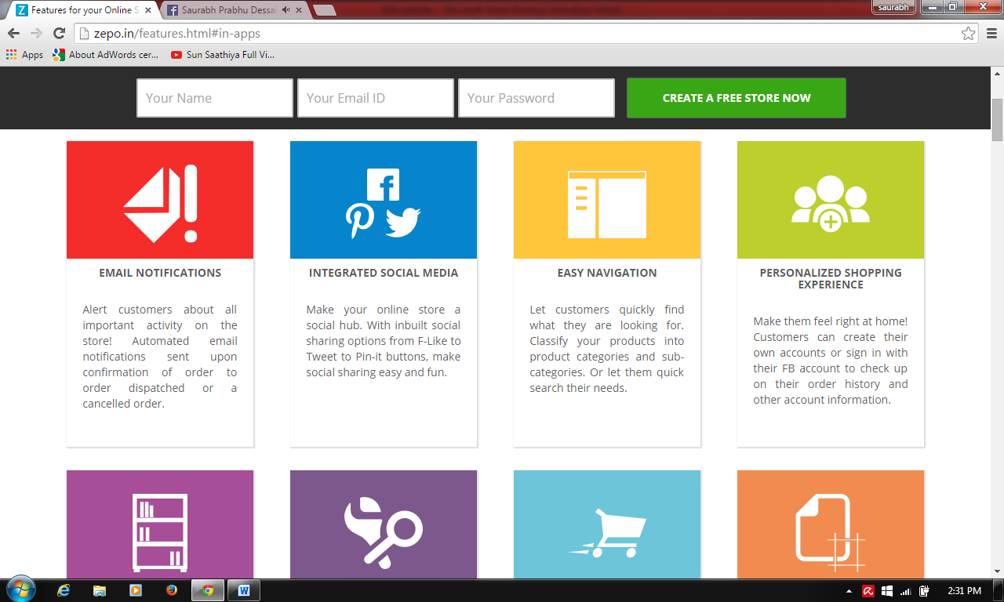

* **Colors to suit the medical profile**
* **No text below the box**
* **Each box is a specialty (Orthopedic, Cardiovascular, Cosmetic, Bariatric, IVF and reproductive sciences, Ophthalmology, Obstetrics and Gynecology, Alternate Medicine)**

**-2-**

Random name

**About us Treatments Hospitals Dentists Alternate Medicine Contact Us**

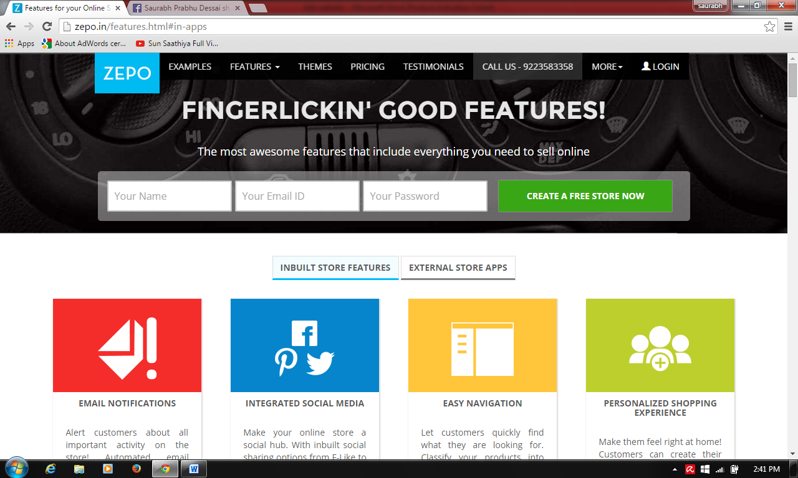

* **Create tabs like above (Inbuilt store features/External store apps) to (Multi-specialty/Super specialty)**
* **Boxes with Text**
* **Manipal Hospitals Goa, Nusi Wockhardt Hospital, Vision Multispecialty Hospital, Dr. Kolwalkars Galaxy Hospital Goa**
* **Super specialty (Vision Care Super Specialty Eye Hospital, Ponda IVF clinic and Endoscopy Center)**

**-3-**

**Similar Page for Dentists**

**-4-**

**Similar page for listing the A.M centers**

|  |  |  |  |
| --- | --- | --- | --- |
| **Treatment** | **Duration** | **Cost** |  |
|  |  |  | **Enquire** |
|  |  |  |  |